What we need:
- We need all job roles
- List of 3 questions and answers for qualification of types all job roles - Jennifer
- Backend documents - standard info docs
- Avature integration endpoints - API call to get the candidate information, for dispositions - Tom
- AI agent trigger indicator when the candidate clicks on the link

Get Started with requisitions:
- 600-800 jobs, 30k offers, 200+ stations, top 20 stations consists 50% of recruiting (roi)
- Build to easy replicate for various companies - TOS (Feb, 26)
- Have the ability to edit the questions easily
- Double negatives, dialect - need a call
- How many are completing the call, visibility - success metric
- Call flow set up - scheduling if the candidate wants to drop the call?
- If call not completed - hold on sending information, restart call from where it was left off

Qualifier Agent - Inbound
- So the in reviews will go to humans. And if they qualify we then put it through the flow again? - not going back into Nurix flow
- What is the method to detect forging of the interview, or impersonating the candidate.

Follow Up Agent
- What are the exact sop/steps/script for the onboarding process, which this agent needs to follow. - Handled via text

Scheduling Agent
- Do we do scheduling from the Agent or is it taken care of by the other system? Or is that there are no human calls, it's just that humans review these ad hoc by listening to the recording. - Solved with Text as of today.

Onboarding Agent - Onboarding portal will send out the text and emails.
- In onboarding agents, do we expect to make outbound calls at regular intervals, or do we expect it to be inbound calls or both.
- Or do we have only outbound for status changes and inbound for users to get updates on their status?
- If for status changes, we have outbound calls, then will you trigger it or expect us to use Avature webhook and poll and make the calls.
- What are the exact sop/steps/script for the onboarding process, which this agent needs to follow.

Compliance
- Will you send the message to make the inbound call to the ai agent only after 10 days? or do we have to handle it on our side?
- For alternative process, do we do a realtime HITL or do we schedule the call with a human evaluator?

Integration
- Our preferred approach is to let the candidate call on a particular number and verify their identity and then go through the screening process. We don’t recommend using web ui/clicking on links to make this screening, as this has a lot of factors that will impact the quality. Factors like internet connection, browser compatibility, permissions etc. - Twilio or texcommunication
- How will we get the data from Avature for the candidates that needs to be followed up for incomplete documentation.

End to End Flow
- How do we do follow ups? Do we call them back at regular intervals? Or do we send them text/email where the candidate calls back, or do we do both?

Summary of the call
- For “in review” candidates - We will be able to post the full transcript on any field provided in Avature, with a summary of why the candidate is in review.

Sep 15th:
- For the 3 questions shared would it be possible to share actual positive and negative statements from candidates? This will help LLM to determine the answers more accurately.
- Do we have screening/deterministic questions to be asked during the qualification. Such as - TSA cleared, can work in overnight shifts etc - depends on the length of call
- Do you need visual citations in the transcript or just the summary highlighting why a candidate is in review or pass? - need both
  - If you need visual citations, are you ok to proceed with just summary citations in phase 1? - yes - need a mock up for both versions
- Are we supposed to score at a question level? What is the scoring range? Criteria? Weightage - Scoring not needed. 2 right answers, 1 review answer - disposition if each question is pass or in review
- Avature integration endpoints: Sandbox is being set up
  - Get API to fetch candidate details
  - Post API, field to send dispositions
- Dialer decision - Twilio

Notes from call:
- Click on the link and you will get a call from number in about 60 seconds - Outbound call - preference to do this on a link that can be sent
- Can we do both a link on the browser and an outbound call if they have an issue?
- Might not go-live with New York region
- Unifi dependent - Email should go to the candidate. When the clicks on the link, land on unifi page, pass on the lead details (webhook to trigger the event) - the lead should be sent to Nurix with the lead details (Avature API call)
- When we build for TOS might not get access to websites - need to figure out the landing page with the specific brands
- Questions can change based on requisitions, customers will have different sent of questions for different roles

Sep 22nd:
- Consent while submitting the application? - when a candidate fills the form
- How should the call be initiated: this involves the below - a link will be sent to the candidate to initiate the phone call - outbound
Retry -
Google voice calling - https://support.google.com/voice/answer/9262934?hl=en&co=GENIE.Platform%3DDesktop
  - Custom landing page with domain URL for screening - This should be maintained by Unifi. Based on this we will be able to arrive at the next steps of all details we will need from the avature API call, will Nurix make the call or will Unifi be able to send all details in the first call.
  - This consists of the link to be clicked on for the candidate to take the interview
  - Or a fallback to click for a phone call. which will tell the candidate that they will receive a call in 60 seconds
  - Or the candidate can call a number directly and go ahead with the screening.
- Avature integration: We will need sandbox access to Avature to analyse the API call to be made or the information we will need in the call trigger
  - The API call that needs to be made when the candidate clicks on the link and the information needed. We can ideate either this will be a single API or should Nurix also make an API call to get additional details.
  - Attributes to pass dispositions. This will need a post API and list of all fields and conclude on data to be populated in what field.
- Telephony - It was decided on the call that Twilio will be the choice. We can discuss further on how to proceed with this, where the Nurix team can set up the integrations on our test account and then move all changes once Twilio is secured at your end. This will not be a blocker for us to proceed with the integration. - Twilio is being procured.
- one set of questions for the POC, but will need to solve for multiple versions of questions as the use case evolves in the production environment.
Sep 25th:
- Call trigger logic: allowed duration from first sms: 96 hours - where is this status stored?
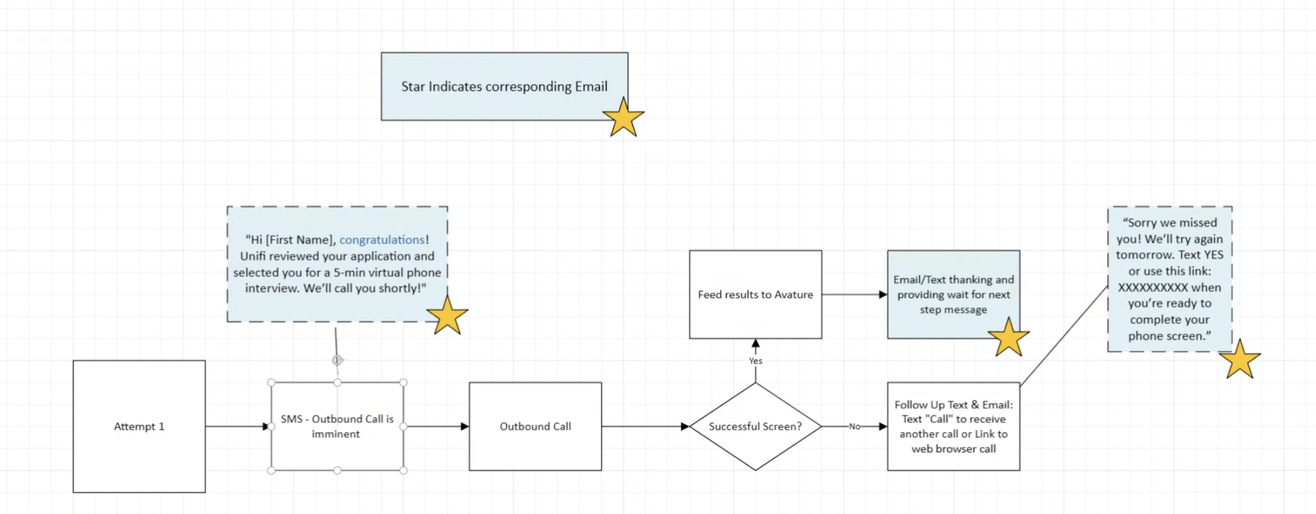
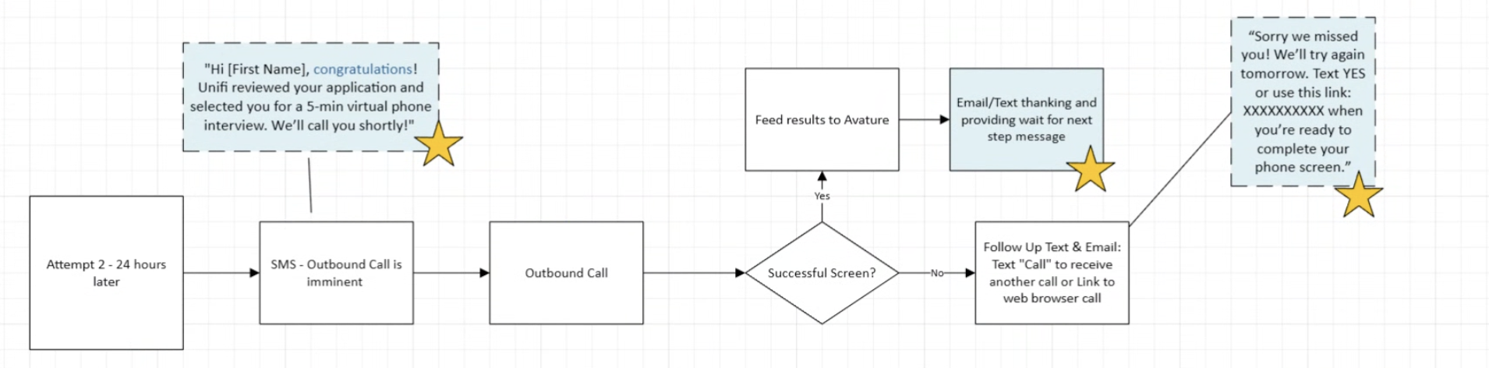
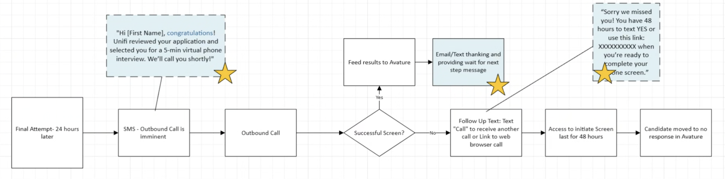

- Volume - 7k-8k per month, 200-300 per day
- Need a static message of how many minutes - approximately in 5 minutes
- Calls can happen 24 hours
- First call attempt if candidate does not pick the call - send text message
  - Call me back after two days - agent will say we will send a text message and link - agent should say great connecting with you followed by message
  - If call drops due to any reason - send text for this scenario - say yes to pick up the conversation from there
- All 3 questions needs to be answered for screening completion
- Uptime of the webpage, rate limiting, integration will have to be maintained by Unifi - full end to end integration should be done
- Weblink can have a fallback - click here to get a call now
- Compatibility of the widget - List of browsers supported, associated devices

Oct 6th:
- Alignment SMS integration to trigger the call
- Avature API endpoints and access - read only access to see the data specific to a candidate - assess the attributes
- Attributes in avature to post the dispositions
- Web integration of the voice agent

Oct 13th:
- Do we need to make sure that all three scoring goals are covered in the answer or any one or two needs to be there. For example, Should the answer cover all detect awareness of safety, willingness to act, and respect for procedures.
- For one of the questions, if the candidate for example says, I will help if i can is that fair? Or if they say, i will leave my work and first help them? is that right? what should be done to handle this.
- we plan to handle false positives/negatives by making the agent repeat and confirm the whole answer if it is short and only the summary if it is long answer to confirm. Hope this works.
- @Abhishek Jain to get structure of end users answers and reasoning. We will share this on the Tuesday's call
- Alignment SMS integration to trigger the call
- Avature API endpoints and access - read only access to see the data specific to a candidate - assess the attributes
- Attributes in avature to post the dispositions - share the list of attributes
- Web integration of the voice agent
- Agent will be available 24 hours - webhook/API to be shared by Nurix - with sample responses
  - User authentication is needed - screening portal in Avature

How do u expect us to send the audio file - as a link or the file
No human intervention as of now

Agenda: Oct 23rd
- Agent voice: The agent has been configured with a male voice as the script has Alex. Would the preference of the agent be a male voice or a female voice. based on preference we will make the edit
- If the candidate says that the name or role is incorrect then what do we do? Should we gracefully end the call
- Candidate screening decision: pass or in review, answer for all 3 questions. What is the passing criteria? all the answers should be a pass or any 2?
- Timelines:
  - Avature endpoints
  - Set up from Unifi to trigger the agent
  - Disposition endpoint from avature
  - Web link set up

